Mechanism-guided discovery of photocontrolled materials and reactions

Julia A. Kalow
Northwestern University, Evanston, IL 60201 USA
jkalow@northwestern.edu
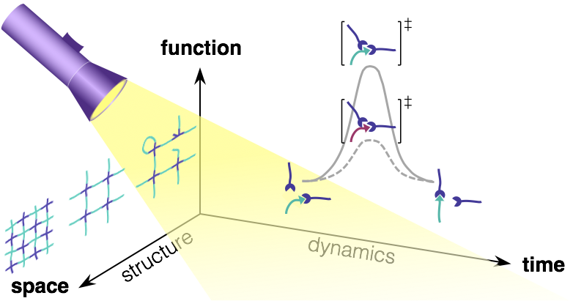

The Kalow lab interrogates and exploits the relationship between molecular reactivity and macroscopic properties to discover polymeric materials relevant to human health and sustainability. We approach “reactivity-property” relationships bidirectionally: in reactivity-directed materials discovery, we use synthesis and physical organic chemistry to tune reactions occurring within polymer networks composed of reversible covalent bonds. We translate changes in reactivity into macroscopic responses, ranging from recyclability in elastomers to photocontrolled stiffness in adaptable hydrogels. In properties-directed reaction discovery, we design photochemical reaction mechanisms that target desirable photophysical properties. Based on this principle, we have discovered a catalyst-free photopolymerization to produce n-type π-conjugated polymers, and a selective photoinduced cross-coupling of polyhalogenated dyes. Across these projects, light provides precise, tunable, and noninvasive spatiotemporal control over molecular reactivity.

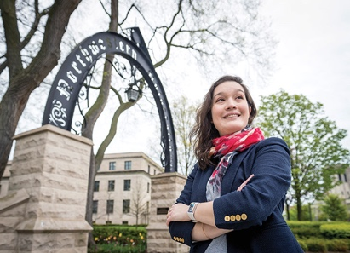
Bio: Julia’s research goal is the development of strategies to control the synthesis and properties of polymeric materials with light. Her group’s work has been recognized with the Air Force Office of Scientific Research Young Investigator Award, a NSF CAREER award, and the Sloan Research Fellowship. She obtained her BA at Columbia University in 2008, where she studied chemistry and creative writing, then pursued graduate studies at Princeton University under the supervision of Prof. Abigail Doyle. After completing her PhD in 2013, she was a postdoctoral fellow at MIT with Prof. Timothy Swager. She started her independent career at Northwestern’s Department of Chemistry in July 2016.

